Project Report Templat

1. INTRODUCTION

1.1 Overview

*A leading Web Design Company & Digital Marketing Agency with unmatched

Capabiities.

*Customized and insight -driven solutions that maximize Business efficiency &

Capability.

1.2 Purpose

*TechPro is a multi-faceted company which prides itself in mobile app.

2. Problem definition & design thinking

2.1 Empathy map

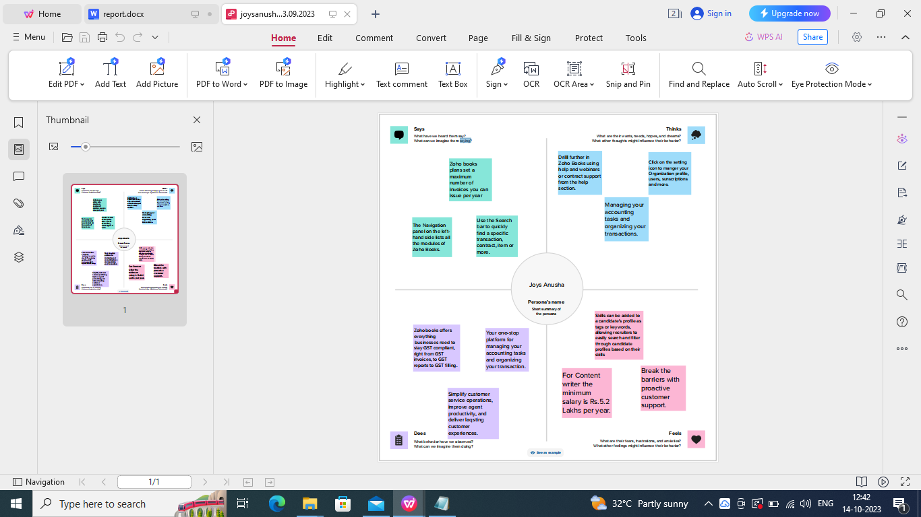

2.2 Ideation & Brainstorming map

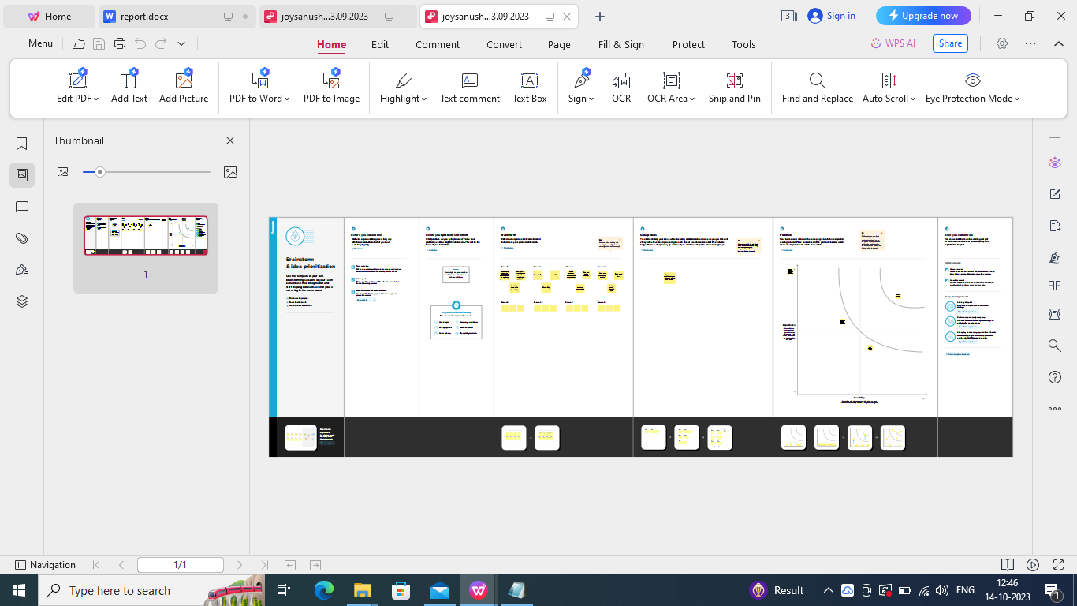

3. Reslt

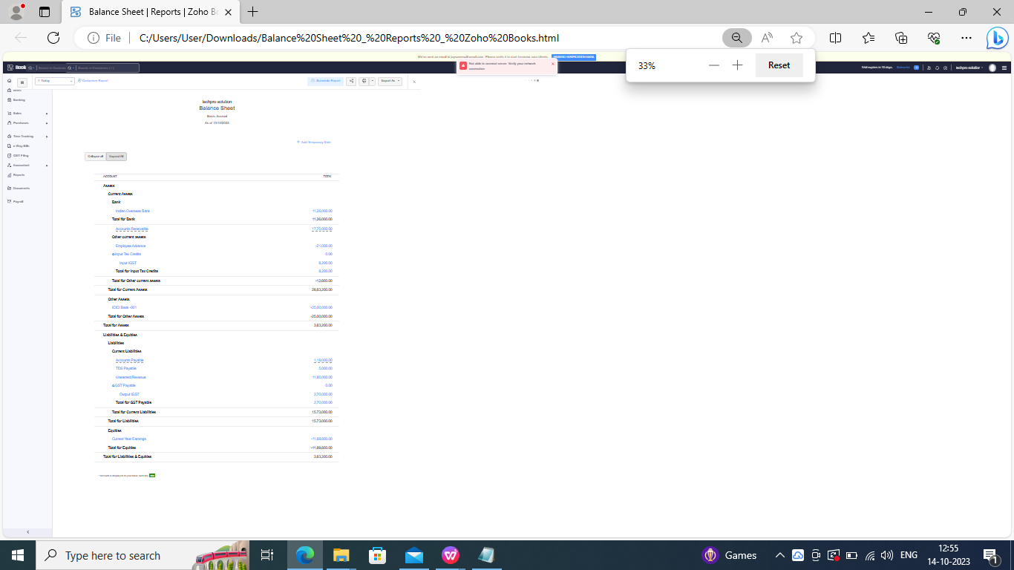

1. Advantages & disadvantages

ADVANTAGES

*Polyethylene contact-wall,hollow on the inside connected blocks connected together by double nylon straps

.

DISADVANTAGES

*Sports tire barriers are “usually better than the SAFER barrier” when it comes to head-on and large-angle impacts.

5. Applications

*an online accounting application that takes care of the account needs of your business.

*online payments

*To ask(someone)for something (such as money).

* It improves your stamina.

6. Conclusion

Thus program has be successfully executed

7. Future Scope

The potential opportunities and prospects in a particular field, industry,or career.

8. Appendix

A. Source Code

https://github.com/joysanusha2023/urban-aura-interiors_NM2023TMID22734